git version:
The command is used to check the version of git.

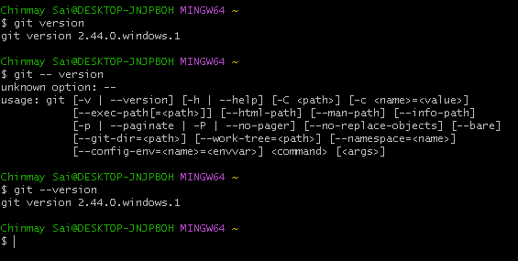
git help :

Displays the commands available and use of them.

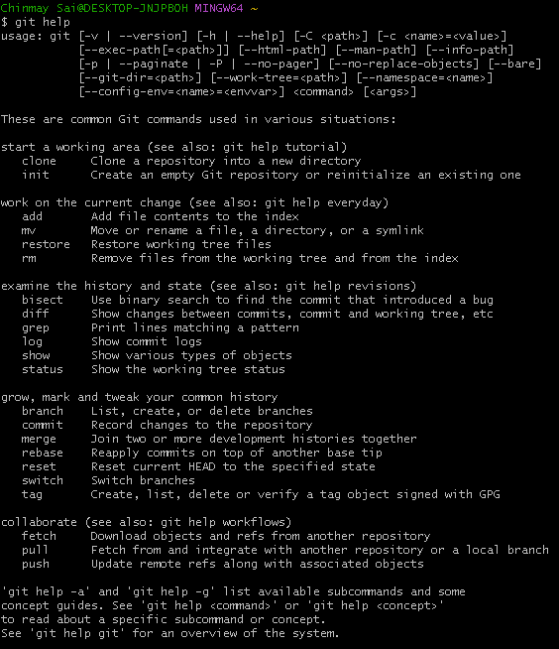

All the commands of git are case sensitive.

Git help command : Opens the we browser with the documentation of the command
git help clone ----Opens the documentation of clone command.
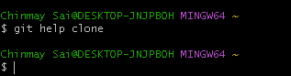
Browser with documentation of clone command.

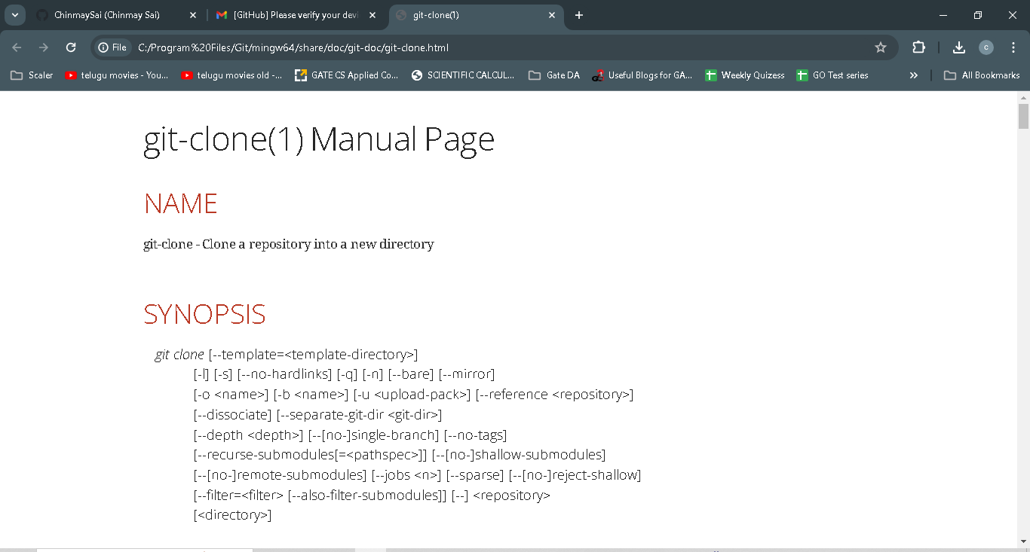

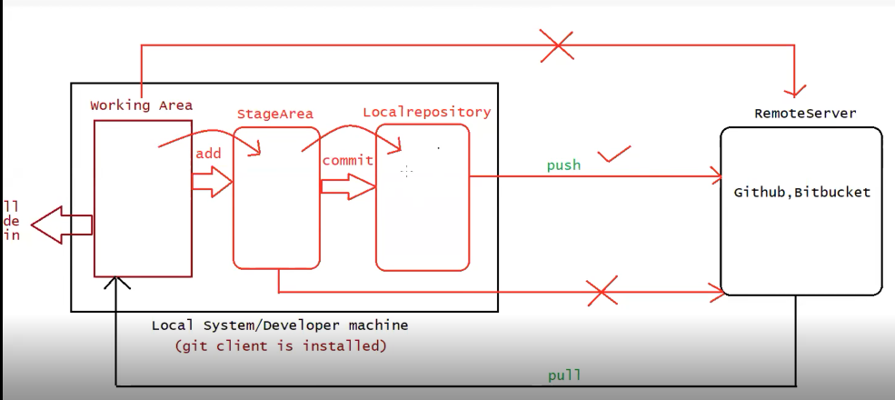

git config :
It is used when the git software is used for the first time.

The command will set the develop identity like name, email id,....
The configuration will be used for every push operation encountered.

It will show Con-fig of git if it is Present.

If it already Present we can delete the config and set it again.

git config –list:
command is used to provide the list of Configurations.

We need to give the Username and Email for setting the Configurations

To set User name

git config –global user.name ”ChinmaySai”

To set the Email

git config –global user.email ”yanamalachinmaysai106@gmail.com”

Configured the Username and Password

Below is the screenshot for show Origin

If we want to delete the Config the Configurations and reset it again .We can delete in the

C:/Users/Chinmay Sai/ -----Delte the .gitconfig file above and set the Configurations again.

git config --list –show-origin : Displays the location of git configuration holded by git software.

Global--- It indicates that user can work with git commands from different drives in computer.

git init :

A folder will be created in the developers workspace and inside the folder source code will be placed.

Only if the git Software identifies our folder then only we can push the code.

We need to mention to git software that from which folder we need to push the code to server.

The Command internally one folder called .git

.git is used by git software to identify the folder which should participate in pushing to local and remote repositories.

Above is Folder created post exceuting git init.

git init is the first command which we execute any other git Operations.

Once it sees the Master the git will get activated.

.git maintains the stage area and local repository.

git status:

Used to check the status of files in working directory.

Consider we have one file Demo.java which has been saved in working directory and if we check the status of that file.

Currently the file is untracked.

To add the File to Stage Area :

git add Demo.java

to get the status of Files.

git status:

Git normally gives the output in the following ways :
Untracked Files: These files are still present in the working directory and can’t be committed
to local Repository or Remote Repository. Untracked files will be off Red Colour
Tracked Files :These files are moved from working directory to stage and can be committed
to local Repository or Remote Repository. Tracked Files will be of Green Color
Modified Files : These files are present in the working directory and these files can be staged or it can also be restored to normal phase

Now we have one more file in Working Directory .

From the above screenshot we could see that there is one file in the stage area and one file in working area.

Adding Demo -Copy to Stage Area :

We Could see now that both the files have been moved to Stage area in the above screenshot.

To Unstage the files from staged area to Working Area :

Now we will bring unstage Demo.txt .

git rm –cached Demo.txt

Now Demo.txt has been moved from stage area to Working Area.

Now there is one file in the stage area and one file in Working area.

To push all the files from workspace to Stage Area:

git add .
git add --a

Now if we make changes to the any of the file :
Consider we made changes to Demo.txt file

If we want the File to move to stage area:
git add Demo.txt

To restore the file to previous position in working area.

git restore Demo.txt : To restore the contents of the file .

Before Restoring

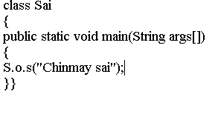

git restore Demo.txt

Post restoring the File content.

The files that are ready for commit should be present in stage area

Syntax :
git commit -m <Some Message>

git commit -m “First Commit” -----To Commit all the files to local Repository from Stage area.

To Commit only specific files :

git commit -m “Second Commit” filename

Steps that will be followed to create a remote repository and push to remote repository :

1.Open github by providing the credentials
2.create a repository
3.To perform Push operation we need the following commands

git branch -M main
git remote add origin https://github.com/ChinmaySai/JavaProject.git
git push -u origin main

We could see from the above it has been changed from master to main.

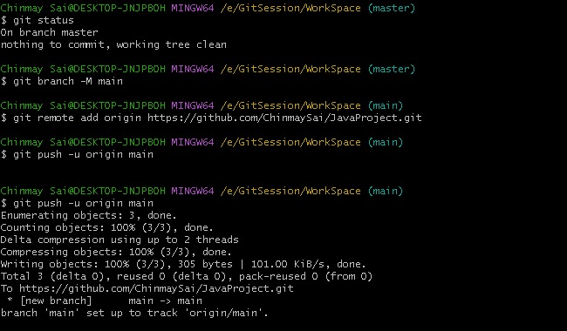
once we run git push -u origin main ---A browser window will open for Authentication.

The Git hub website with the two files that we have pushed .

Team Leader will create an Github project and push all the code on to that Project.
Developers will take the code from that Project.
Developers will install Git Client.
Team lead will share the required credentials.

Initially Developers will clone(copy of Project) the Project into their workspace.

Lets suppose we have a new developers and they want to clone the project into workspace.

Consider we have new developer who has recently joined. They need Clone the code .

Copy the url from the github for the repository that which you are willing to clone.
Go to folder where you want to clone the code.

Once we clone the code it will be present in developers machine.

The developer has made changes to one file (Demo).

We could see that one file has been modified. We have made these change in Developers machine.
Now we need to push the modified file to Remote repository

We Could see from the above that the file has been added --->Committed --->pushed to repository

Below is the screenshot from which we can see that the changes were updated in repository.

Developer 2:
One more developer is trying to clone the code

They have cloned the code.

Developer 1 will make changes to his code.

We could see from the above that we made changes to Demo.txt filename

Post that we have pushed the updated code on to the repository.

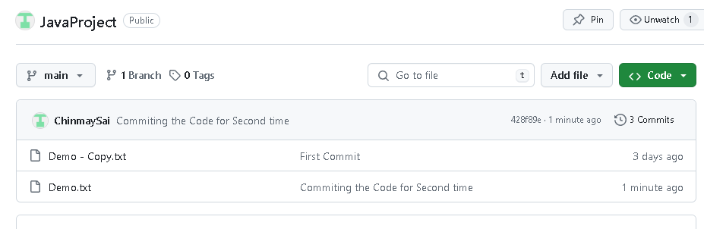
We could see the code has been updated.

Developer will not have these changes reflecting in the system.

So if Developer2 wants have the updated code then he need to pull the code.

We have pulled the latest code in the above and below screenshot we could see that file got updated.

Git Clone Synatx :
git clone <url>

Git Pull :
git pull

